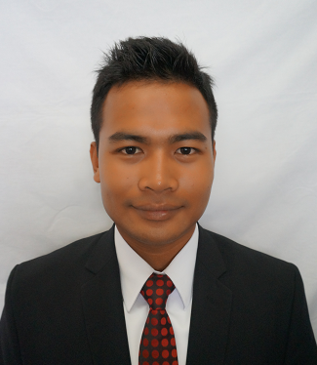

**MOHAMMAD AMIRUL IZZAT AMINUDDIN**

[Izzat_rmnvr@yahoo.com](mailto:Izzat_rmnvr@yahoo.com)

30539 Kampung Banggol Tok Jiring,

21060 Kuala Terengganu,

Terengganu Darul Iman

019-9381851

IC. 930529-10-6069

Age 22

Birth date May, 29th,1993

Gander male

Religion Islam

Race Malay

Country Malaysia

Marital Status Single

**REFERENCE**

DR Korlina Madzhi

Internship Programme Coordinator

(Bachelor of Engineering ( Hons ) Electronic ( Instrumentation )

03-55436072

**OBJECTIVES**

* As I finish my study, I am looking forward to expand my knowledge and provide opportunities for personal and professional growth in terms of **technical** and **managerial skills**.
* I will use my **excellent interpersonal and communications skills** to perform the given task and responsibilities in contribution towards the organization’s goal.
* I would like to be one of the **key person** in the top management of the organization.

**EDUCATIONS**

University Teknologi Mara (UiTM) 2012-2015

Bachelor of Engineering ( Hons ) Electronic ( Instrumentation )

CGPA 3.18

Metriculatin Pahang 2011-2012

Programme module 2

CGPA 3.16

Sekolah Menengah Teknik Terengganu 2006-2011

Programme SPM

Result 5A’

**WORKING EXPERIENCE**

Sabasun Hyperuncit

Duration : March 1st 2012-august 31st 2012

Department : Inventory

Position ; Staff

Job : Control all prices of goods in stores

Description : If there changes of price, inventory will moderate all cash machine to follow new price that have been changed

**SKILL**

COMPUTER S

* Proficiency in LOGO!
* Expert in using Microsoft Office
* Able to use Code Block
* Intermediate knowledge using Matlab

SELF

* Strong physical
* Capable to multi working
* Able to work in team
* Open-minded
* Good problem solving
* Able to lead and work with diverse teams and people
* Willing to help, listen and learn

**EXTRACOCURICULUM ACTIVITIES**

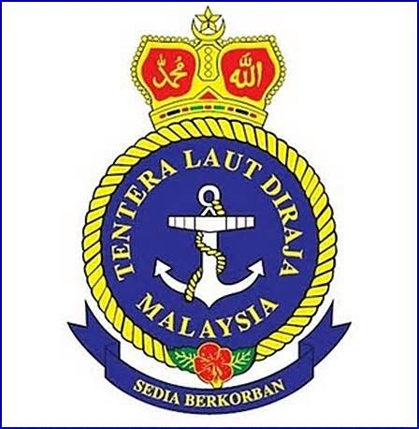

**Reserve Officer Training Unit (ROTU)**

* Participated in Annual Training (ACT)1 at KDSK
* Participated in Annual camp Training (ACT)2 at KDSI 1
* Sailing to Pulau Pinang with KLD Tunas Samudra
* **Gold medallist** for Men’s swimming Navy Sport Carnival
* **Gold medallist** for volleyball Navy Sport Carnival
* **Director** for Team Building Siri-3(Tasik Kenyir)
* participated in **Istiadat Pentauliahan DiRaja Pegawai Kadet PALAPES IPTA ke-33**
* Participated in **Wellness X 14**
* **Dean’s list** semester 1 3.63
* **Dean’s list** semester 5 3.65

**Mini project**

Title : Smart Whirlpool

Position : Programmer

Description : Machine where it can wash, spin steam and fold the cloth.

* **Science Carnival 12’**

Title : Electron

Position : Programmer

Description : Showed how the Electron flows in wire.

* **Sport carnival**

**Gold medallist** for Rugby

Proficiency:

0 – Beginner

5 – Intermediate

10 - Excellent

|  |  |  |
| --- | --- | --- |
| **Language** | **Spoken** | **Written** |
| Bahasa Malaysia | 10 | 10 |
| English  German | 6  4 | 6  4 |

2012-2015

2011-2012

**LANGUAGE**